80 High Street
Egham
www.das-kuechen-studio.co.uk/solutions

CARB
Cellular Automata Rule Base

A Notation

Sunil Vanmullem

Contents

Introduction 3
Problem Statement 3
Previous Options 4
CARB Notation 5
CARB Evaluation 5
CARB Evaluation Speed 6
Benefits of CARB notation 6
CARB Diversity 6
Fine grained modification of Rules 7
Multi-state CARBs 8
3D CARB 8
Encryption 9
Shuffle Scrambling 10
CARB migration 10

Introduction
We introduce the CARB notation

Problem Statement
A general purpose notation for Cellular Automata that could express all possible state transitions of two-state two-dimensional cellular automata.

Most notations investigated are able to describe a subset of the possible transitions,

CARB is a form of “Neumann Binary” notation extended to an 8 cell neighbourhood with simple compression,

Previous Options

General binary rules notation

The notation of General binary rules has the "C/N/S/B" form, where:
C - specifies the count of states in the rule (0..C-1).
N - specifies the neighborhood type: NM stands for Moore, NN for von Neumann.
S - specifies the compressed string defining the configurations where a cell survives.
B - specifies the compressed string defining the configurations where a cell is born.

Strings defining S and B parts specify the 0/1 state for every possible configuration. For enumerating all possible neighborhood configurations the "N,NE,E,SE,S,SW,W,NW" order is used. For example S010000...0 means "Survival on an alive N neighbor", B1100...0 means "Birth on no neighbors or on a single N neighbor". To make the S/B strings shorter a simple compression is used. 0s are represented as "a", 1s as "b". 3 and more occurrences of the same character are shortened by specifying the count of occurrences and a character.

Neumann binary rules notation

Neumann binary rules are represented as a string of digits. The first digit specifies the count of states, 2, 3, or 4; the rest of digits define the transition table - the state a cell will have in every possible configuration. For enumerating all possible neighborhood configurations the "ME,N,E,S,W" order is used.

Example:
Fredkin2 rule has the following definition:
201101001100101101001011001101001
The first digit, '2', tells the rule has 2 states (it's a 1 bit rule).
The second digit, '0', tells a cell in a configuration ME=0,N=0,E=0,S=0,W=0 will get the state 0.
The third digit, '1', tells a cell in a configuration ME=0,N=0,E=0,S=0,W=1 will get the state 1.
The fourth digit, '1', tells a cell in a configuration ME=0,N=0,E=0,S=1,W=0 will get the state 1.
The fifth digit, '0', tells a cell in a configuration ME=0,N=0,E=0,S=1,W=1 will get the state 0.

Life rules notation
Life rules are defined in the "S/B" form, where:
S - defines counts of alive neighbors necessary for a cell to survive,
B - defines counts of alive neighbors necessary for a cell to be born.

An example of a life rule is
Conways 23/3

CARB Notation
A CARBs is a sequence of digits that represent a state transition table for a 2 state, 8 neighbour, 2 dimensional Cellular Automata . The position of each digit in the sequence identifies the initial state and the value of the digit expresses the transitioned state.

The initial state is a “State Bitmap” a binary representation that enumerates the neighbours in the sequence NW N NE E SE S SW W ME.

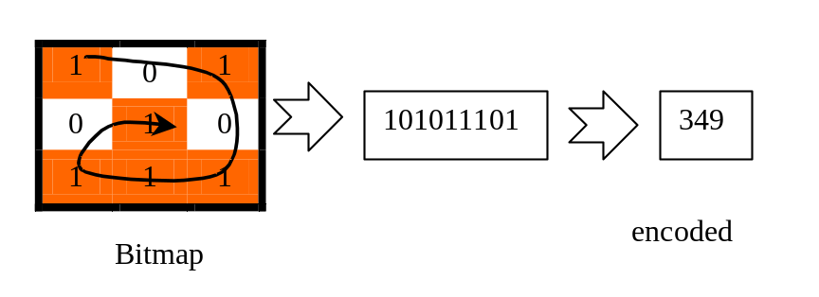

As each digit position is a 9 digit binary number, there are 512 digits in a CARB. Base64 encoding is used to reduce the number of digits to 86.

An example of a CARB is Conways game of life, 23/3 in life notation, is as follows

<CARB states=1>
ARcXfBd8fMAXfHzAfMDAABd8fMB8wMAAfMDAAMAAAAAXfHzAfMDAAHzAwADAAAAAfMDAAMAAAADAAAAAAAAAAA
</CARB>

And CARBs can be interestingly readable

<CARB states=1>
TheQuickBrownFoxJumpedOverTheLazyDogTheQuickBrownFoxJumpedOverTheLazyDogTheQuickBrownF
</CARB>

CARB Evaluation
The CARB forms the set of rules for cells in a cellular automaton grid (cell universe). The CARB is applied to each cell in the input (initial state) grid, evaluating the cell bitmap, to produce the output (outcome state) grid.

CARB Evaluation Speed
A CARB sequence is a lookup table. During evaluation a “State Bitmap” of each cell is used as the position in the CARB sequence to determine the new state of the cell.

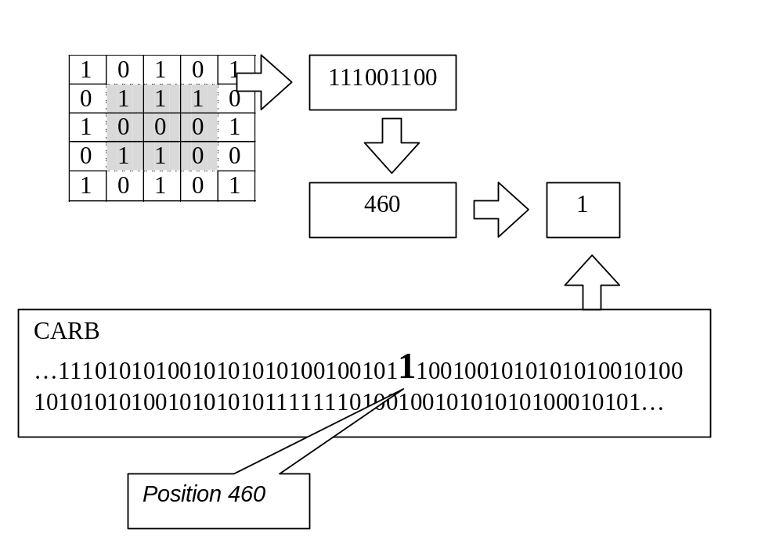

Benefits of CARB notation

The lookup table nature of CARB requires very little computational effort and makes the CARB notation fast to evaluate.

CARB Diversity
As each digit can have a value of 0 or 1 there are 2⁵¹¹ (6.70390396 × 10¹⁵³) possible 2 state CARB sequences.

If it took one second to evaluate each CARB it would take 10¹⁴⁶ years to evaluate all possible CARBs.

Fine grained modification of Rules

CARB notation allows fine grained modification of rules that lends this notation more useful to analysis using Genetic Algorithms

For example running conways life for 100 generations from a number of initial grid configurations results in the following:
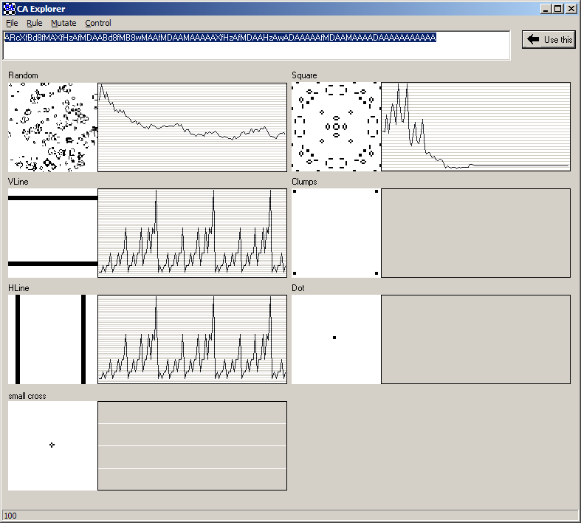

if the last digit in the sequence mutates from an A to a B, on the same initial grid configurations it may seem trivial to change just one digit in the 512 digit rule sequence but has a significant effect.

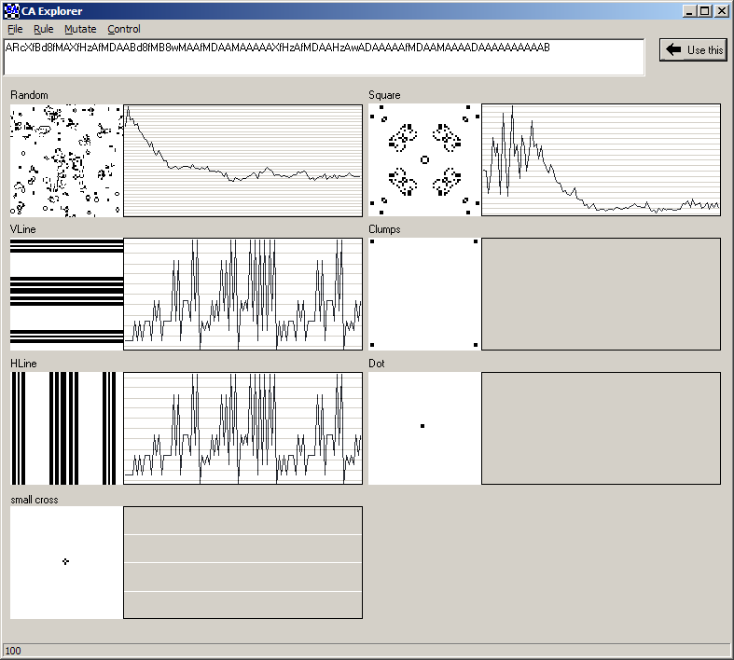

Multi-state CARBs
The CARB notation can be extended to accommodate multiple states.

<CARB states=2 bits=2>
<STATE value=0></STATE>
< STATE value=1></STATE>
</CARB>

3D CARB
The CARB notation can be extended 3D grids. In a 3D grid, each state bitmap contains 18 neighbouring cells resulting in 2¹⁹-1= 524,287 binary digits in a 3D CARB. This could be reduced to 87382 base64 digits, or further through other compressions.

There would be are 2⁵²⁴²⁸⁷ (10¹⁵⁷⁸²⁶) possible 3d CARBs, an unimaginable number to evaluate.

Encryption

Shuffle Scrambling
In a cell universe of w*h cells, with a pre-requsite CARB and an initial universe state.
- Apply the CARB to the universe
- Read the data from the universe into a binary stream
- Read scrambling instruction tuples of data from the binary stream (row/col, index, amount)
- read w*h bits of data from the data to be scrambled into a grid
- Apply tuples to the grid
- Write out the data from grid
- repeat from step 1 until there is no more input data
a | b | c | d | e
f | g | h | i | j
k | l | m | n | o
p | q | r | s | t

original
c | d | e | a | b
f | g | h | i | j
k | l | m | n | o
p | q | r | s | t

Row, 1, 3
c | d | m | a | b
f | g | r | i | j
k | l | e | n | o
p | q | h | s | t

Col, 3,3
c | L | M | I | b
q | r | k | j | f
e | n | O | S | D
a | t | p | g | h

After many iterations

CARB evolution and mutation

In a cell universe usually the CARB is homogenous. Ie all cells have the same rules.

Rules could be devised that changed the CARB itself depending on the CARBs of the surrounding cells.

For example the universe could initially have cells with no CARB
The universe is populated with cells with different CARBS
At each step the following could occur:
- For an empty cell, ie no carb, If there are two or more neighbours and all have the same carb, the cell will adopt the carb , ie there will be a birth
- Cells can deterministically mutate based on how many times they have changed state and the bitmap neighbourhood. For example if a particular bitmap has been seen more than a certain number of times by a particular cell,the CARB digit for that bitmap should flip.
- CARBs can be assigned as sexually dimorphic being male of female so that births can only happen between different sex cells
- For an empty cell, If there are exactly 2 neighbours, the cell will adopt a blended carb formed by taking alternate bits from each carb.
- For a cell with a CARB if it is surrounded by 4 or more cells in which a competing CARB is more prevalent than theirs, there will be a fight and the cell will die i.e. have no CARB

http://psoup.math.wisc.edu/mcell/rullex_gebi.html
http://psoup.math.wisc.edu/mcell/rullex_nmbi.html
http://www.mirekw.com/ca/rullex_life.html
http://mathworld.wolfram.com/CellularAutomaton.html
there are approximately 10⁸⁰ atoms in the observable universe http://en.wikipedia.org/wiki/Observable_universe

